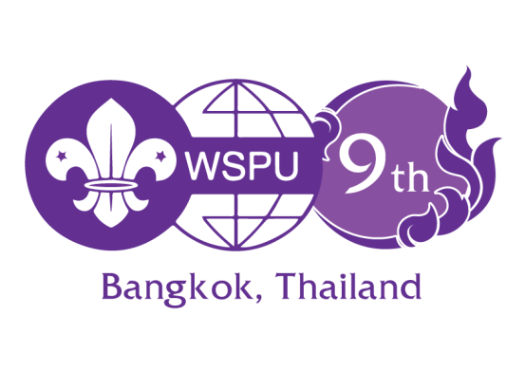 Country ………………………………..

REGISTRATION FORM
9TH WSPU GENERAL ASSEMBLY
Bangkok, Thailand
12 – 14 November 2018

- We prefer this form to be completed through online registration service available at https://register.parliament.go.th/wspu9/
- To be completed (in BLOCK LETTERS) only by people accredited to their National Scout Parliamentary Association, one form per individual
- Please type or print clearly and return this form to the WSPU-GA secretariat by e-mail (wspu9th@gmail.com) and CC to WSPU Secretariat (wspu@scout.or.kr)
- Please return this form together with a copy of your payment and a photocopy of your passport face page by NO LATER THAN 30TH SEPTEMBER 2018 to the GA Secretariat copied to WSPU Secretariat.
- The Registration form can be downloaded from the official website at https://www.parliament.go.th/ewtadmin/ewt/parliament_parcy/main.php?filename=interparliament2_scout
- Please completed all pages

Registration Category
Please check the box representing your registration category

  - I am the delegate invited by the National Assembly of Thailand.
  - I am an additional delegate (fee: USD 400, excluding accommodation and traveling costs).
  - I am the young leader invited by the National Assembly of Thailand.
  - I am an additional young leader (fee: USD 400, excluding accommodation and traveling costs).
  - I am an observer from National Scout Organization/Association or others (fee: USD 400, excluding accommodation and traveling costs).
  - I am an accompanying person with Parliamentarians or others (fee: USD 200, excluding accommodation and traveling costs).

Please attach the photocopy of registration fee payment to the WSPU-GA secretariat: wspu9th@gmail.com

DELEGATE DETAILS
Country
Salutation | ( ) Mr. ( ) Mrs. ( ) Ms. ( ) Dr. ( ) Prof. ( ) Other ____________
Last Name
Middle Name
First Name
Name on Badge
Date of Birth | (dd/mm/yyyy)
Title
Position | ( ) Member of Parliament ( ) Officer ( ) Others
Please Specify | ( ) Head of Delegation  ( ) Diplomatic corps  ( ) Spouse  ( ) Press |  |  | ( ) Delegate  ( ) Youth Leader  ( ) Delegation Secretary  ( ) Others:________________
Country |  |  | Zip code
Postal Address |  |  | Phone no. (Include country code)
PERSONAL HEALTH INFOMATION
Blood Type |  |  | Prescribed Medicine
Diet | ( ) Halal ( ) Vegetarian ( ) Non Vegetarian
Food Allergies
Other Specifications
PASSPORT DETAILS
Passport Type | ( ) Diplomatic ( ) Official ( ) Ordinary ( ) Other: _______
Passport Number |  |  | Place of Issue
Date of Issue |  |  | Date of Expiry
TRAVEL INFORMATION
 | Date | Time |  |  | Flight Number
Arrival (Bangkok)
Departure (Bangkok)
Picture | 2” X 2” Digital Passport-Sized Photo  with White Background  200 dpi or better

Hotel request
Please check the box representing your hotel of choice
- I wish to stay at Dusit Thani Bangkok Hotel.
The conference venue, 5 stars hotel.
Single room approximately USD 110 /room/night
The reservation is available under: www.dusit.com/WS2018

- I wish to stay at Furama Silom Bangkok Hotel.
1.3Km from the conference venue, 4 stars hotel.
Single room approximately USD 55 /room/night
The reservation is available under: https://goo.gl/73spxF

- I wish to stay at Mandarin Hotel Bangkok.
1.3Km from the conference venue, 4 stars hotel.
Single room approximately USD 70 /room/night
The reservation is available under: https://goo.gl/forms/gZ6EC8N5uRGupXt83

- I do not need help with the Hotel arrangement. Please indicate your accommodation address…………………………………………………………………………

Panel Discussion attending
- Panel Discussion I : Role of the Parliament to Ensure Lifelong Learning
- Panel Discussion II : Possible Contribution of the WSPU to Achieve SDGs
- Panel Discussion III : Scouting and Parliamentary Roles in Synergizing Efforts in
Response to Global Challenges

Excursion attending
The Grand Palace and the Temple of the Emerald Buddha, 12.30 hour, 14th November 2018
- Attend
- Not Interested

Contact Information
Secretariat, 9th General Assembly of WSPU (about GA)
(Tipco Tower) Rama VI Rd., Phayathai District, Bangkok 10400, Thailand
Tel: +66 2 357-3100 ext. 3160-1, 3249 Fax: +66 2 357-3154 E-mail: wspu9th@gmail.com

Secretariat, World Scout Parliamentary Union (about WSPU in general)
441-1, National Assembly Members' Bldg, 1 Yeouido-dong, Youngdeungpo-gu,
Seoul 150-702, Korea Tel: +82 2 786 4491~2 Fax: 82 2 780 1703
E-mail: wspu@scout.or.kr Website: www.wspu.info

